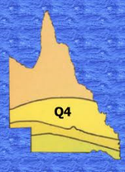

LIONS DISTRICT 201Q4 CONVENTION 2026
Hosted by LIONS CLUB OF ROCKHAMPTON FITZROY RIVER inc.
ABN 57 764 970 329 IA00826 CP0271
District Governor: Lion Murray Wegner M: 0439 828558
Convention Chair: Lion Jenny Hooper M: 0439 466736
Convention Secretary: Lion Kathryn Barrett M: 0438 331265
Email: convention.q4@lions.org.au

REGISTRATION - Q4 CONVENTION 2026
Attendee Details | Person 1 | Person 2
Title (Lion/Partner/PDG etc)
First Name
Last Name
Preferred Name for Badge
Club
Phone
Email address
First Convention? YES/NO
Special Dietary Needs
Other Requirements (if any)
Accommodation If known
Address
Convention Program Preference | Hard Copy ___ or Electronic ___

Would you be interested in a bus pick-up for Saturday Night? Cost of $5. Must be booked by 30 September.
YES NO
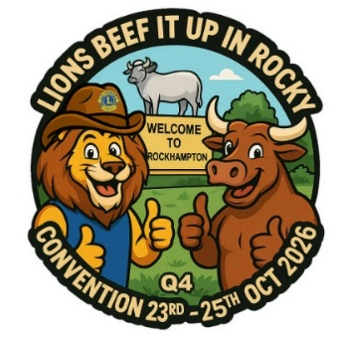
Payment to:
Lions Club of Rockhampton Fitzroy River Lions Convention 2026
BSB: 034 636
Account No: 289562
Reference: Your name and club

Friday night Meet and Greet – Denim and Lace
Saturday Night DG Gala Dinner – Shimmer and Shine in Rhinestone

PLEASE COMPLETE NEXT PAGE

Hospitality Details | Cost | Person 1 | Person 2 | Total
Registration | $10.00
Friday Dinner  (Gracemere Community Centre, Barry St.) | $25.00
Saturday Breakfast | $10.00
Saturday Morning Tea | $5.00
Saturday Lunch (Choice below) | $15.00
Saturday Afternoon Tea | $5.00
Saturday Night Dinner (Frenchville Sports Club  Clifton Street) | $50.00
Sunday Continental Breakfast | Gold Coin Donation | Donation | Donation | N/C
Sunday Morning Tea | complimentary | complimentary | complimentary
Full Package | $120.00
Less Early Bird Payment | $10
Bus Cost if applicable | $5 pp
Final cost

Saturday Lunch Menu Choice Select ONE per person.
___ None ___ Egg and Lettuce Sandwich
___ Ham and Cheese Sandwich ___ Ham, Cheese and Tomato Sandwich
___ Chicken, Cheese and Mayo Sandwich ___ Chicken and Salad Sandwich
___ Salad Sandwich (Vegetarian) ___ Corned Beef and Pickles Sandwich
___ Ham and Salad Sandwich ___ Ham and Salad Wrap
___ Chicken and Salad Wrap ___ Corned Beef and Salad Wrap

REGISTRATIONS: Frank Douglas Phone: 0411 634 650 Email: frank.douglas@bigpond.com
SECRETARY: Kathryn Barrett Phone: 0438 331 265 Email: convention.q4@lions.org.au

